CO224 – Computer Architecture

Lab 06 – Part 2 (Report of comparing Part 1)

Group 01
E/20/381 – Somathilaka A.N.T
E/20/385 – Sriyarathna D.H

Introduction
In this lab (lab 06 – part 2), the data memory hierarchy was further developed by adding a cache module between data memory and CPU, to minimize the delays. This report compares the performance of a less structure and the structure with a data cache.
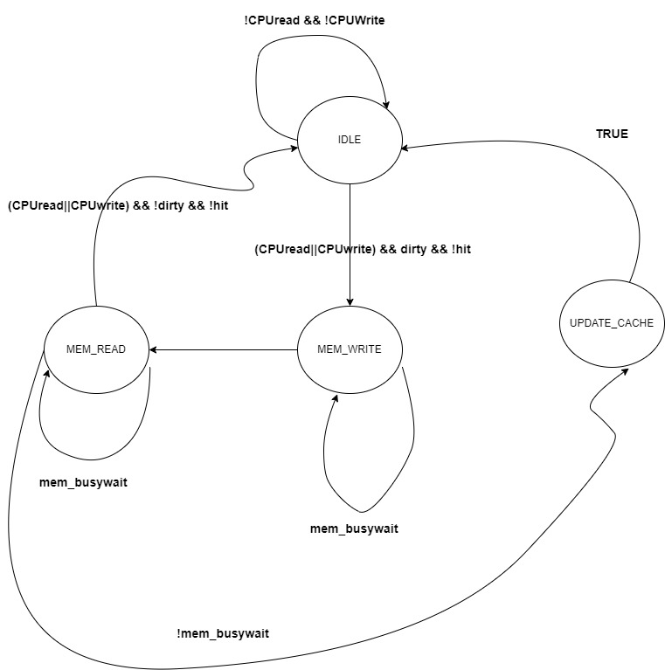
Figure 1- FSM of the cache

The finite state machine consists of 4 states
- IDLE – The default state of the machine when no data requests are being processed
- MEM_READ – Activated when data needs to be fetched from the main memory
- MEM_WRITE - Activated when data needs to be written to the main memory
- UPDATE_CACHE – Activated when the cache needs to be updated with new data

Delays appeared in the cache
- If the existing block is dirty, the total miss penalty adds up to 42 CPU cycles, otherwise it's 21 CPU cycles while a read miss or a write miss
- To compare the tag and extract the values it takes 1.9 CPU cycles.

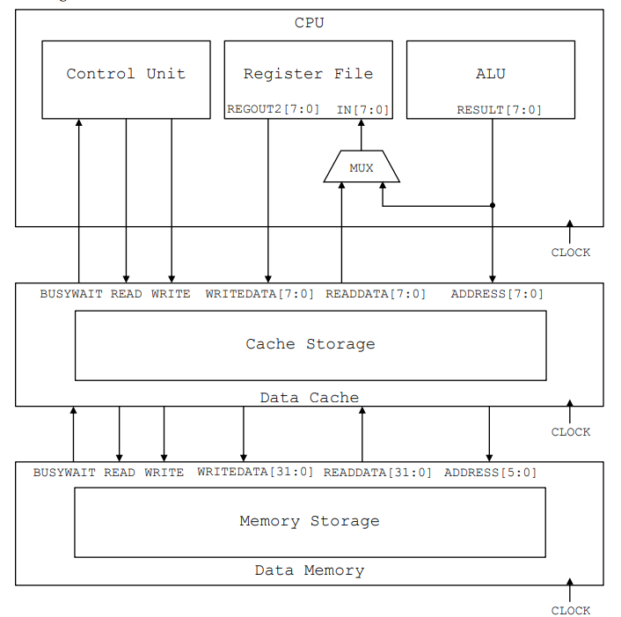
Figure 2 - Memory hierarchy with a data cache

Compare between Cache-less architecture and architecture with a Cache

Compare
Instruction set
loadi 1 0x01
swd 0 1
swi 1 0x00
lwd 2 1
lwd 3 1
sub 4 0 1
swi 4 0x02
lwi 5 0x02
swi 4 0x20
lwi 6 0x20

GTK Wave signal
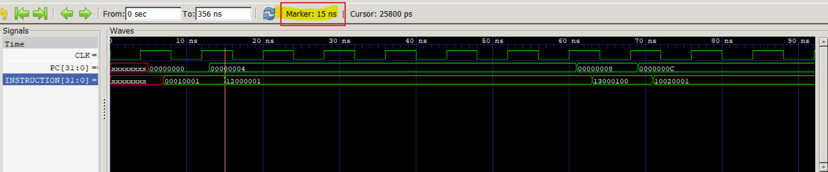
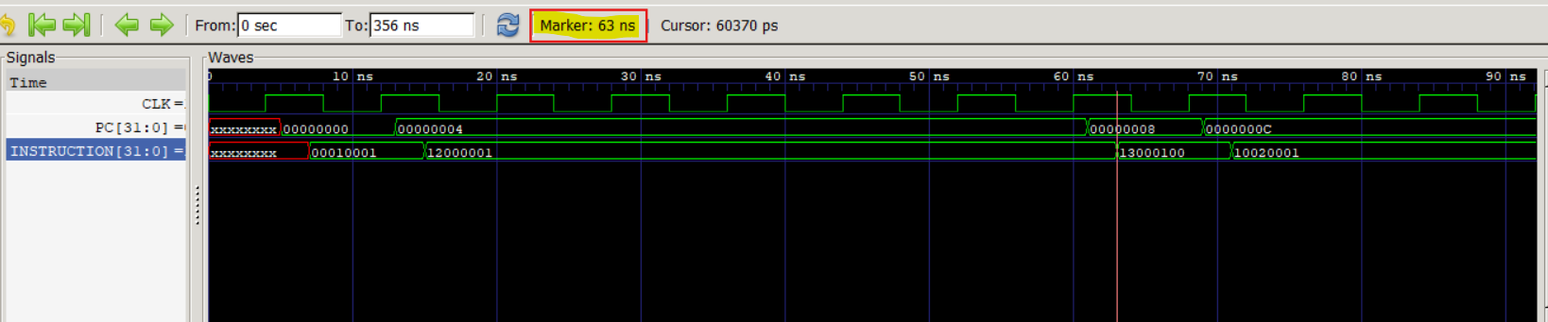
Figure 3 - cacheless CPU behavior on SWD
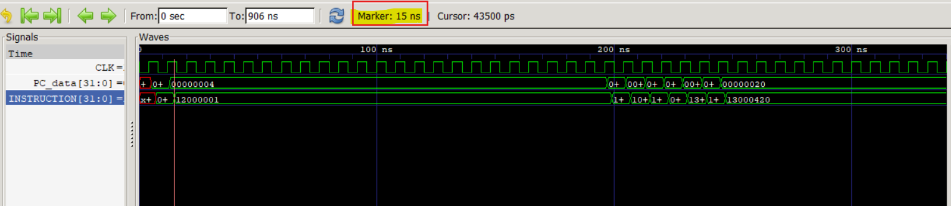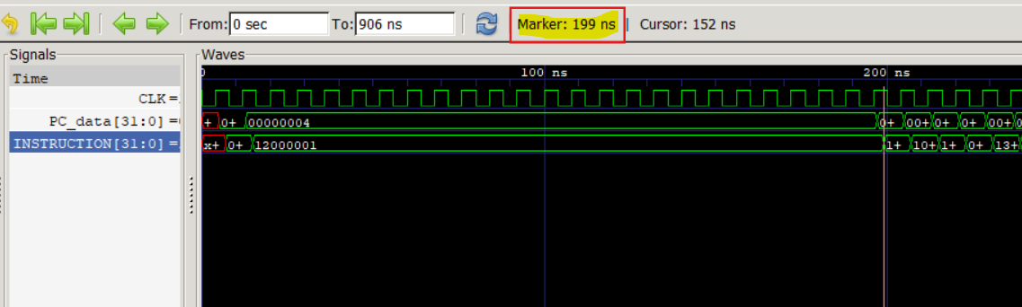
Figure 4 - with-cache CPU behavior on miss
- Since the first SWD instruction is a miss in with_cache CPU architecture it took 184ns to complete the instruction while cacheless only took 48ns.(showed in figure 3 and figure 4 respectively).

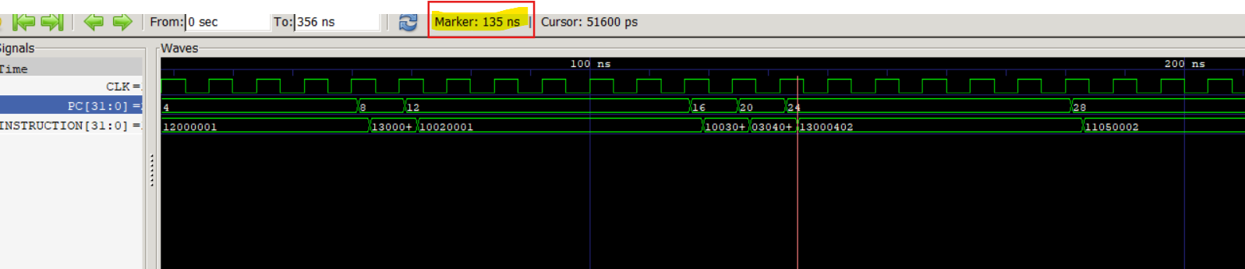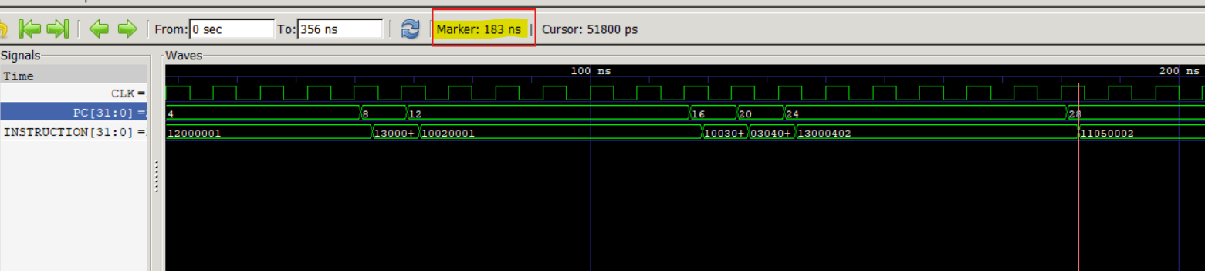
Figure 5 - cache-less CPU behavior on SWI instruction
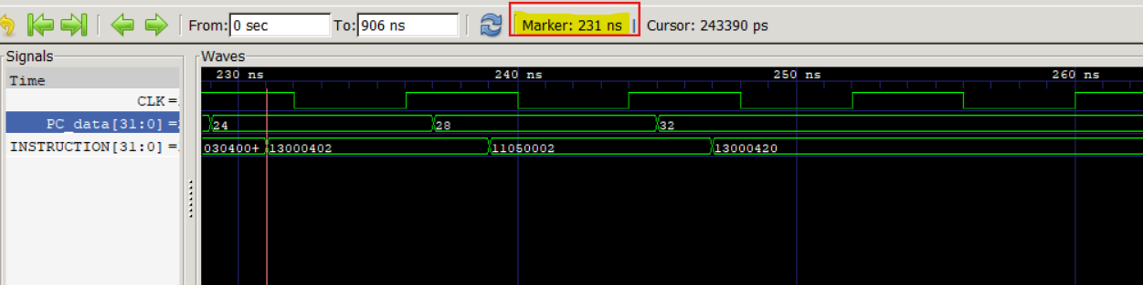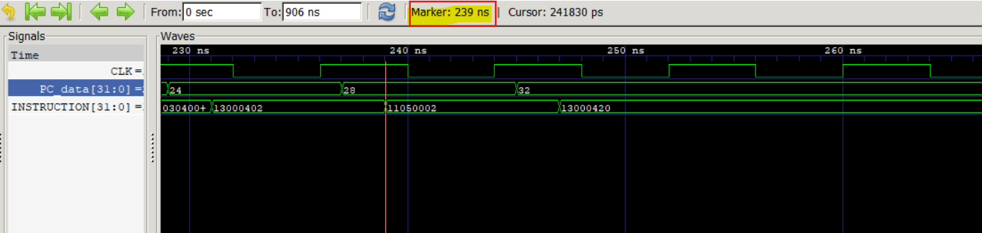
Figure 6 - with-Cache CPU behaviour on a hit
- The 7th instruction in the instruction memory is a SWI which is a hit in with-cache CPU implementation. Therefore it executed within a one-clock cycle without halting the CPU(figure 6).
- Any how the cacheless CPU implementation will take the delay of SWI instructions which is 48ns(figure 5).

Conclusion
When there is more hits than misses cache implementation is more efficient than cache-less.
These are the reasons;
- Temporal locality(availability of recently accessed data in the cache)
- Spatial locality (Data located closer to the data which was accessed recently, would also be available in the cache since the blocks of data were fetched from the memory)
Therefore if the hit rate is higher using a cache may be more efficient since cache is more speed in reading and writing.

Suggestions
In this lab, we are focusing on a cache which uses a direct mapping method which is not very efficient, anyhow using a cache which writes on the rarely used blocks from the cache will be more efficient.
Also, using a buffer memory may increase the efficiency of the cache.

